Research Curriculum Vitae
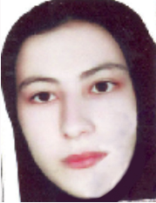

Name: Dr Elham Saberi
Current Position: Instructor of Nursing Education, School of Nursing & Nursing Research Center, Gonabad University of Medical Sciences
Field of Expertise: Instructor of Nursing Education
Email: [saberi.e@gmu.ac.ir]
Phone:051-57223084-داخلی8225

🎓 Education
- Ph.D. in [Discipline], gonabad medical univercity], [student]
- M.Sc. in [Discipline], [mashhad medical univercity], [2016]
- B.Sc. in [Discipline], [shahid Beheshti medical univercity], 2014]

📚 Publications (Selected)

1.ORCID ID Link: http://orcid.org/0000-0003-3646-5590

2.Scopus ID Link: http://www.scopus.com/authid/detail.url?authorId=57979297200

3.Researcher ID Link: https://www.webofscience.com/wos/author/record/AAQ-2746-2020

4.ResearchGate Link: https://www.researchgate.net/profile/Elham_Saberi2

5. Google Scholar Link: https://scholar.google.com/citations?hl=fa&user=zUAchMYAAAAJ

